Please see below screen Shots to see survey results:
- This question has a range from 1 to 5
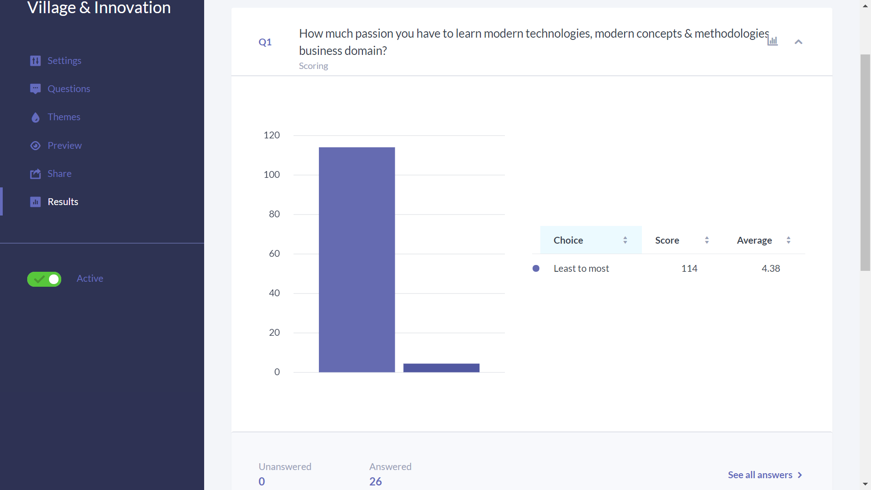
- This question has a range from 1 to 5
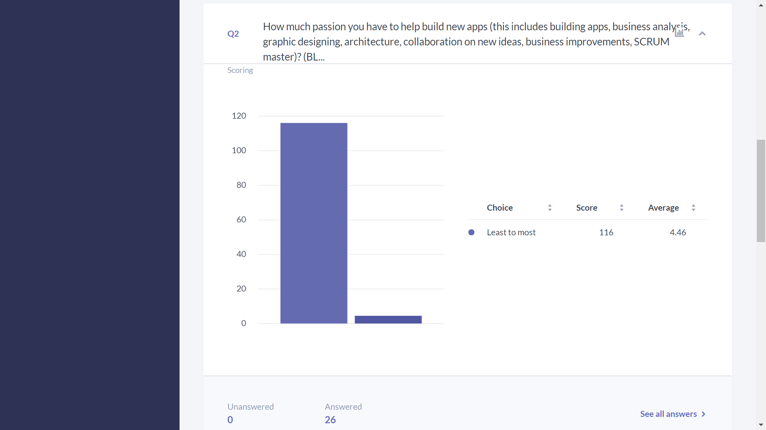

- This question has range from 1 to 5.
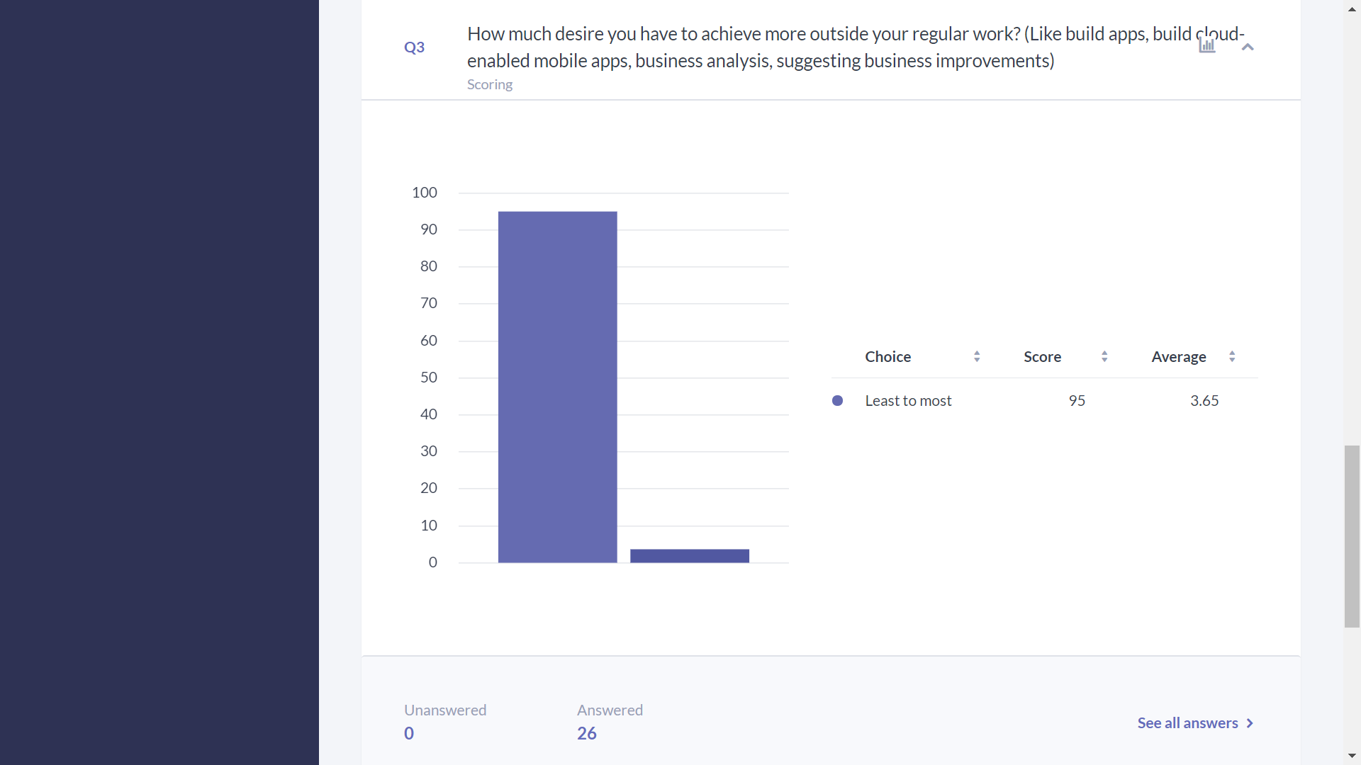
- This question has a range from 0 to 10.
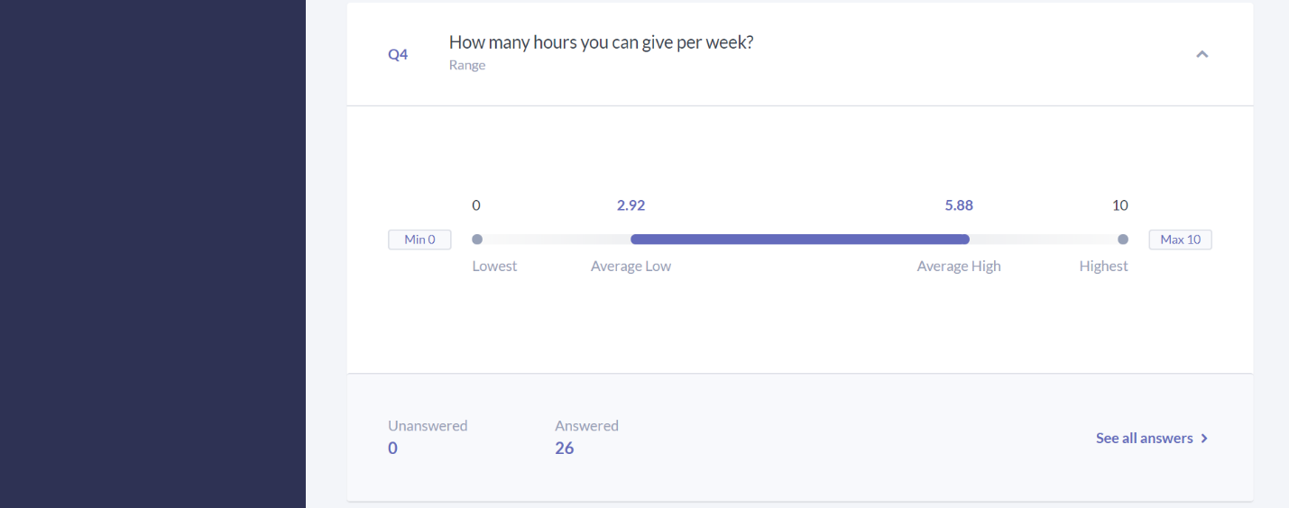

- This question has a range from 1 to 5.
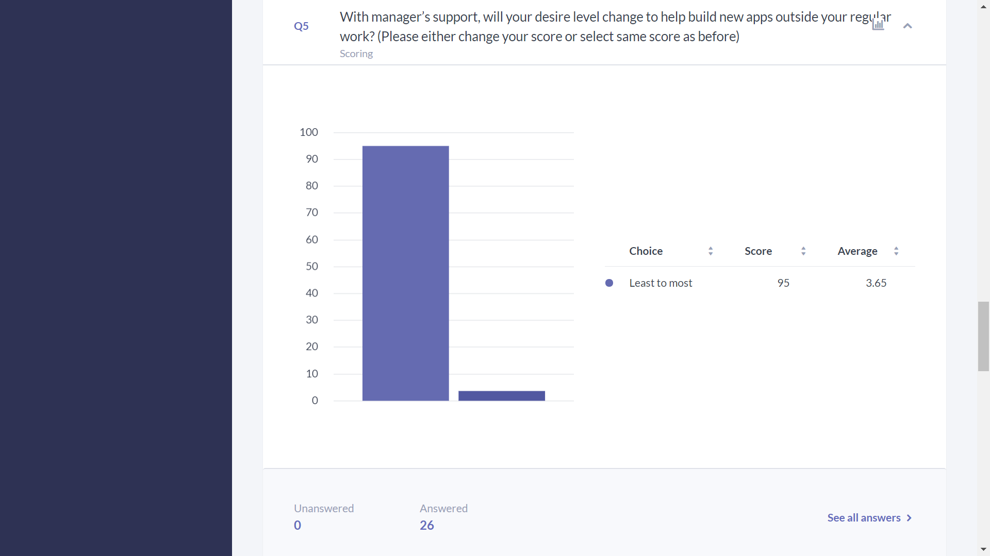
- This question has a range from 1 to 5.
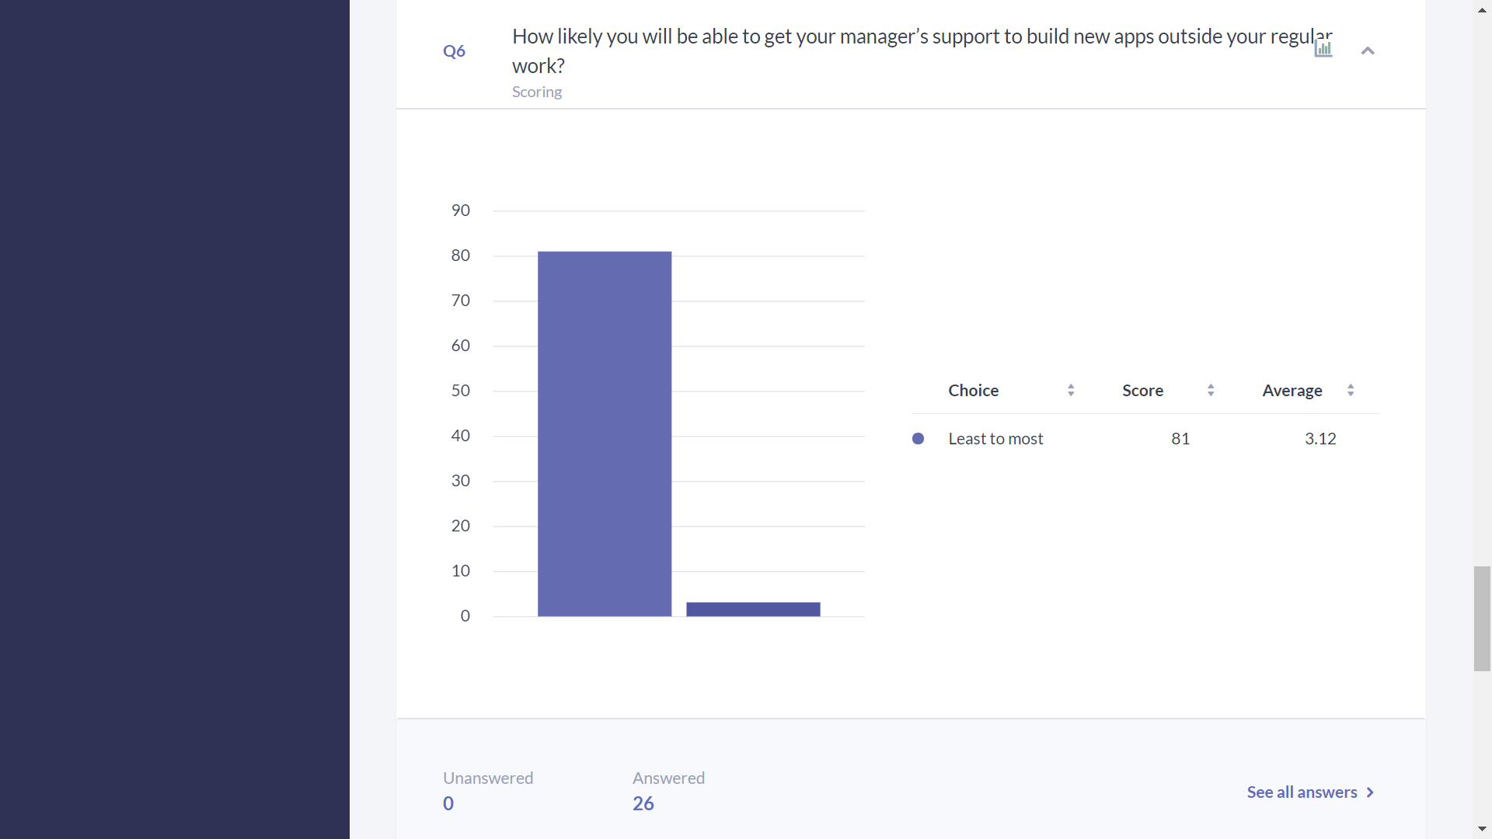

- User comments:
